INFO3315 - HCI  
Human-Computer Interaction  
Student Notes  
Week 4 - myBalsamiq

Outline

* Background to UI Design and Prototyping
* Balsamiq Rationale
* Setting up Adobe Flash in Google Chrome
* Introduction to myBalsamiq
* Managing your Project
* Linking Mockups
* Assets
* Summary
* More Resources

# Background to UI Design and Prototyping

In the real-world there are some additional constraints to think about when using prototyping tools.

Know your UI framework: What UI elements do you have available and what design guidelines do you have to follow. For each platform there are a host of rules:

**Apple Human Interface Design Guidelines**  
[**https://developer.apple.com/ios/human-interface-guidelines/overview/design-principles/**](https://developer.apple.com/ios/human-interface-guidelines/overview/design-principles/)

**Google Material Design Guidelines**  
**https://material.google.com/**

**Note: You are not expected to learn these rules – just be aware of their existence.**

Consequences for failing to follow rules in the real-world:

* Apple will not approve apps for release on the App Store unless they abide by Apple’s guidelines
* Desktop gives more freedom, but respect convention for each OS - Windows UI conventions feel out of place on MacOS. GNOME apps feel strange when using KDE
* Creating UI elements that aren’t in your OS/framework’s native set - or you don’t have existing library code that implements these elements - will dramatically increase the cost and complexity of software development

# Balsamiq Rationale

Balsamiq produces UI mock-ups that appear hand-drawn to avoid the perception that the mock-ups have been visually-designed. By adding too much polish too early in the project, stakeholders can start to fixate on the design, instead of seeing the big picture of the UI’s ideation.

The Balsamiq team explain this in a blog post at <https://blog.balsamiq.com/creating-polished-wireframes/> and the following excerpts are helpful for understanding this rationale:

Wireframing is not meant to be doing visual design, and this is why people make their wireframes as devoid of designed elements as possible.

* **Focus on Function over Form**  
  Focus on communicating functionality; wireframes are not for visual design.
* **Illustrate Flow**  
  A minimalist approach does not mean that you should drop elements that communicate your ideas. Arrows and annotation are great ways to indicate flow, and you should still use them.
* **Don't Neglect Content**  
  Lorem ipsum only gets you so far. In Sketchy or Wireframe style, you may want to make it reflect real content when you can. It will help to know how your rules will work with real content.
* **Use Graphic Design Principles**  
  Even though you aren't doing visual design, design principles always help communicate ideas. Contrast, alignment, repetition, etc. are tools for creating hierarchy, organization, and flow in your interface. If you're new to design principles, a book like Robin Williams' very short [*Non Designers Design Book*](http://www.amazon.com/Non-Designers-Design-Book-Robin-Williams/dp/0321193857) is a great primer.

# Setting up Adobe Flash in Google Chrome

We are using myBalsamiq for the UI prototypes - this is an older release of the in-browser Balsamiq software – it has been superseded by Balsamiq Cloud. There is also a native desktop app for Windows and Mac with a 30-day trial, but since the semester is longer than 30 days this will be a problem for you to continue to complete your work.

myBalsamiq’s editor is implemented in Adobe Flash. Since Flash is outdated, insecure and generally terrible, most browsers no-longer have it pre-installed. Those that do tend to wisely disable it by default. Google Chrome has Flash Player installed but disabled, except for a Google approved whitelist. Before we can proceed we’ll need to enable Flash Player for the myBalsamiq website.

**Note: These instructions add a single exception to enable Flash for myBalsamiq only to avoid punching any holes in your PC’s security.**

If you don’t use Chrome, then you can install the Flash Player plugin in your browser of choice. But you are on your own with setting that up. Good Luck. With That.

**Step 1:** Open Chrome Settings  
A screenshot of a social media post

Description generated with very high confidence

**Step 2:** Find Flash settings  
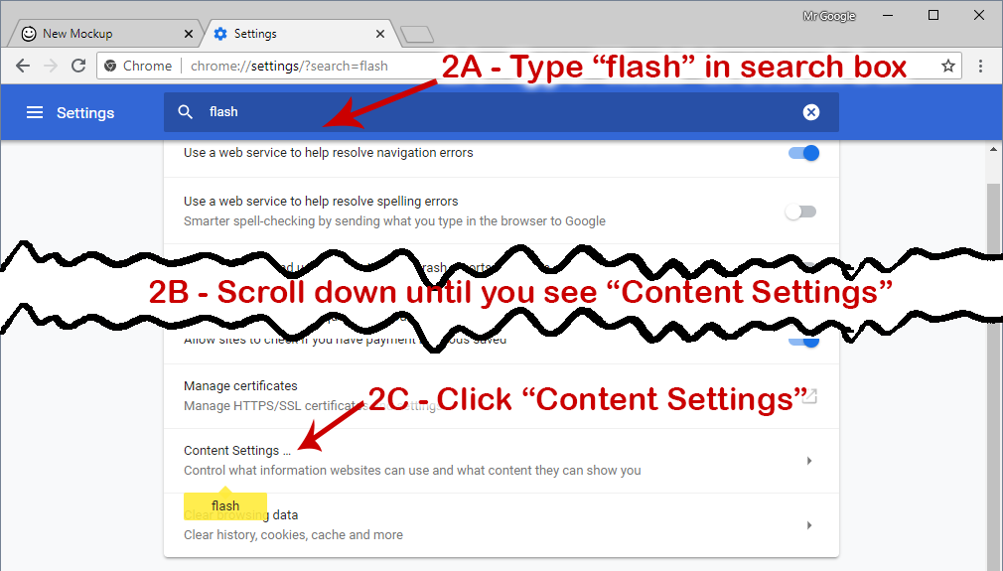

**Step 3:** Find Flash settings (continued)  
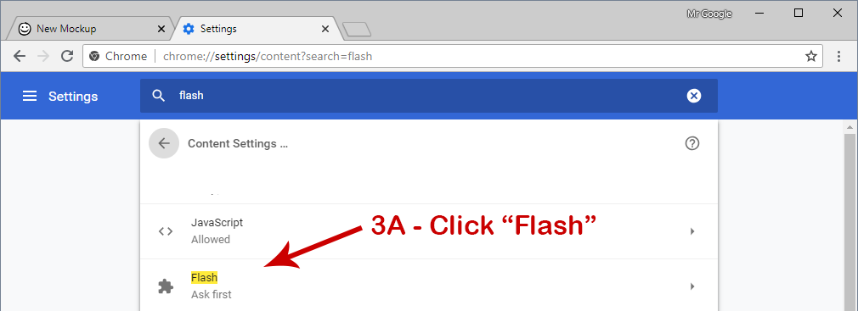

**Step 4:** Add exception rule for myBalsamiq  
A screenshot of a social media post

Description generated with very high confidence  
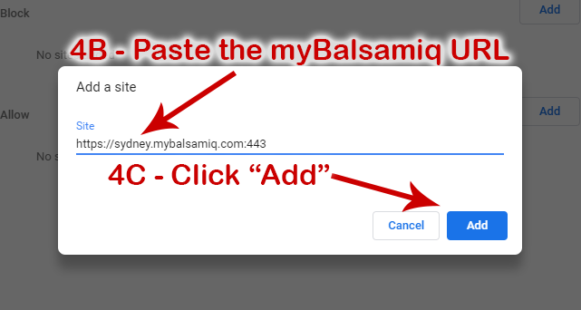

The URL to copy-pasta into the Chrome settings is:  
[**https://sydney.mybalsamiq.com:443**](https://sydney.mybalsamiq.com:443)

We can now (hopefully) use the myBalsamiq software. If you see this message:

**Loading myBalsamiq editor...**[**Flash Player 11.2**](https://get.adobe.com/flashplayer/) **or later required.**

Please check the URL has been added to the Allow list, not the Block list.

# Introduction to myBalsamiq

## Create your account

You will each have received an invite from Balsamiq to your Sydney Uni email address during the week. If you haven’t received this, let your tutor know after checking your emails again.

You will need to create a username and password before you can log in.

The invite email looks like this:

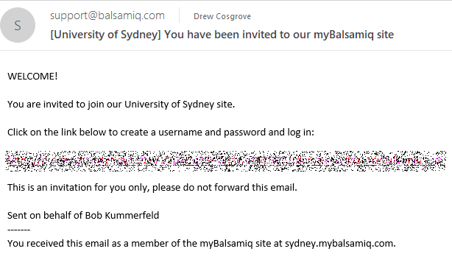

## Log In

The URL for myBalsamiq is [**https://sydney.mybalsamiq.com/**](https://sydney.mybalsamiq.com/)

The log in link is conveniently hidden in the top-right corner of the page.[1]

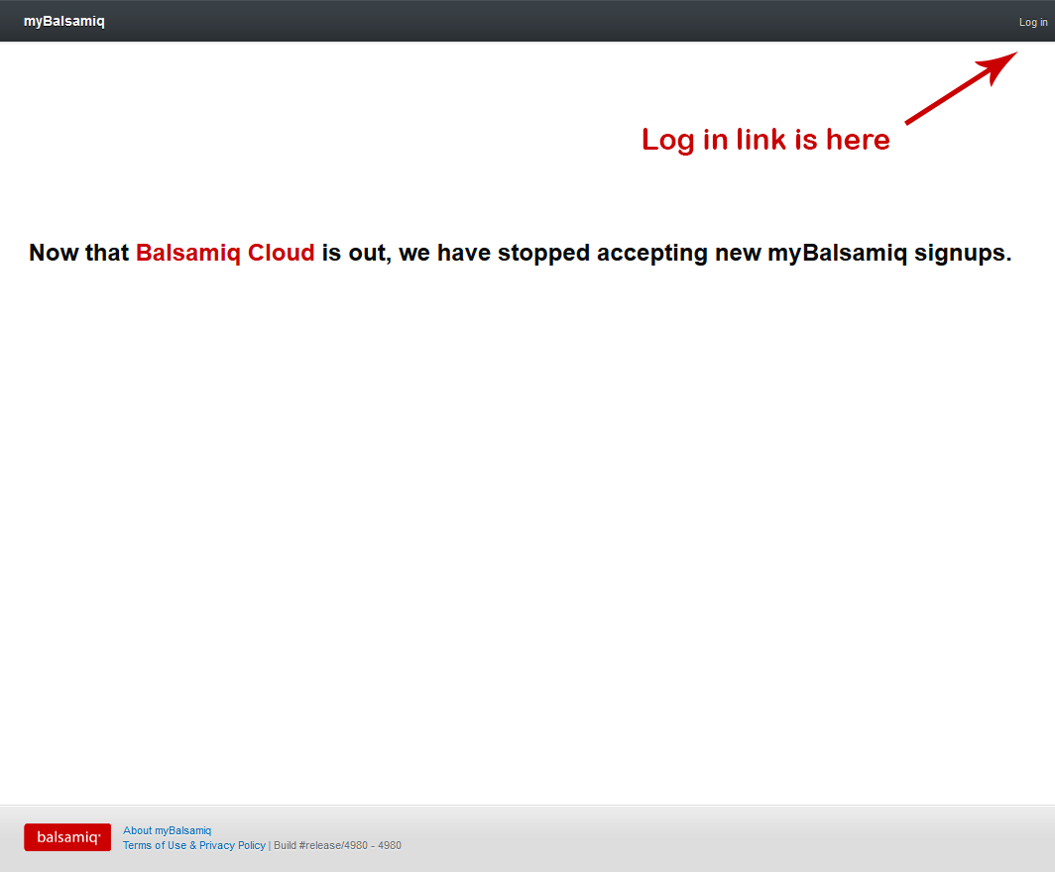

## Projects

We have created a *Project*[2]for each group that was formed in Week 3. You won’t be able to create new projects by yourselves, but you can request your tutors do this on your behalf.

You can view the project(s) that you have access to from the myBalsamiq home screen:

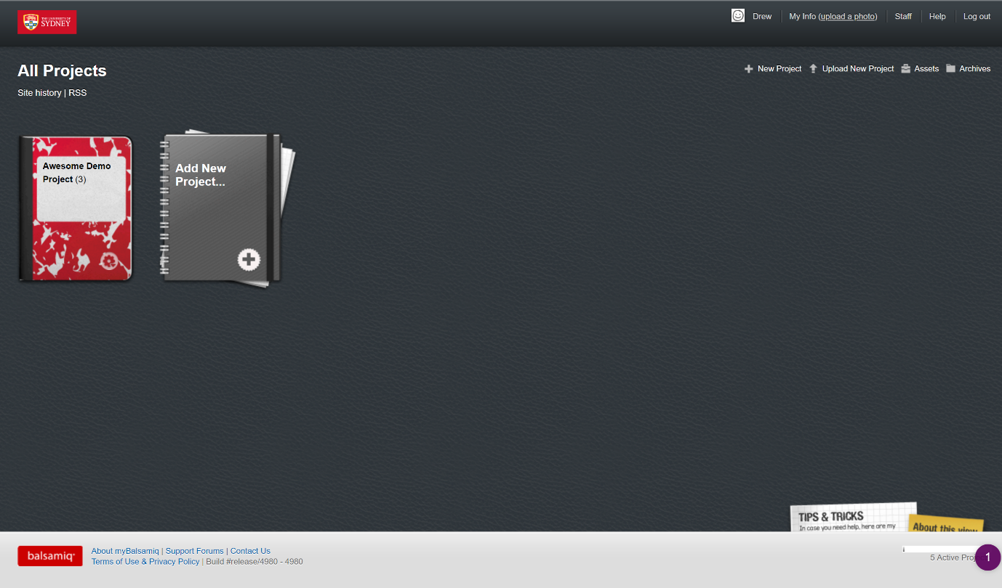

Balsamiq projects can contain one or more *Mockups*. Each mockup represents a screen of your prototype UI. To start, you can create a new mockup to experiment with. You won’t be asked to name your new mockup until you try to save it later.

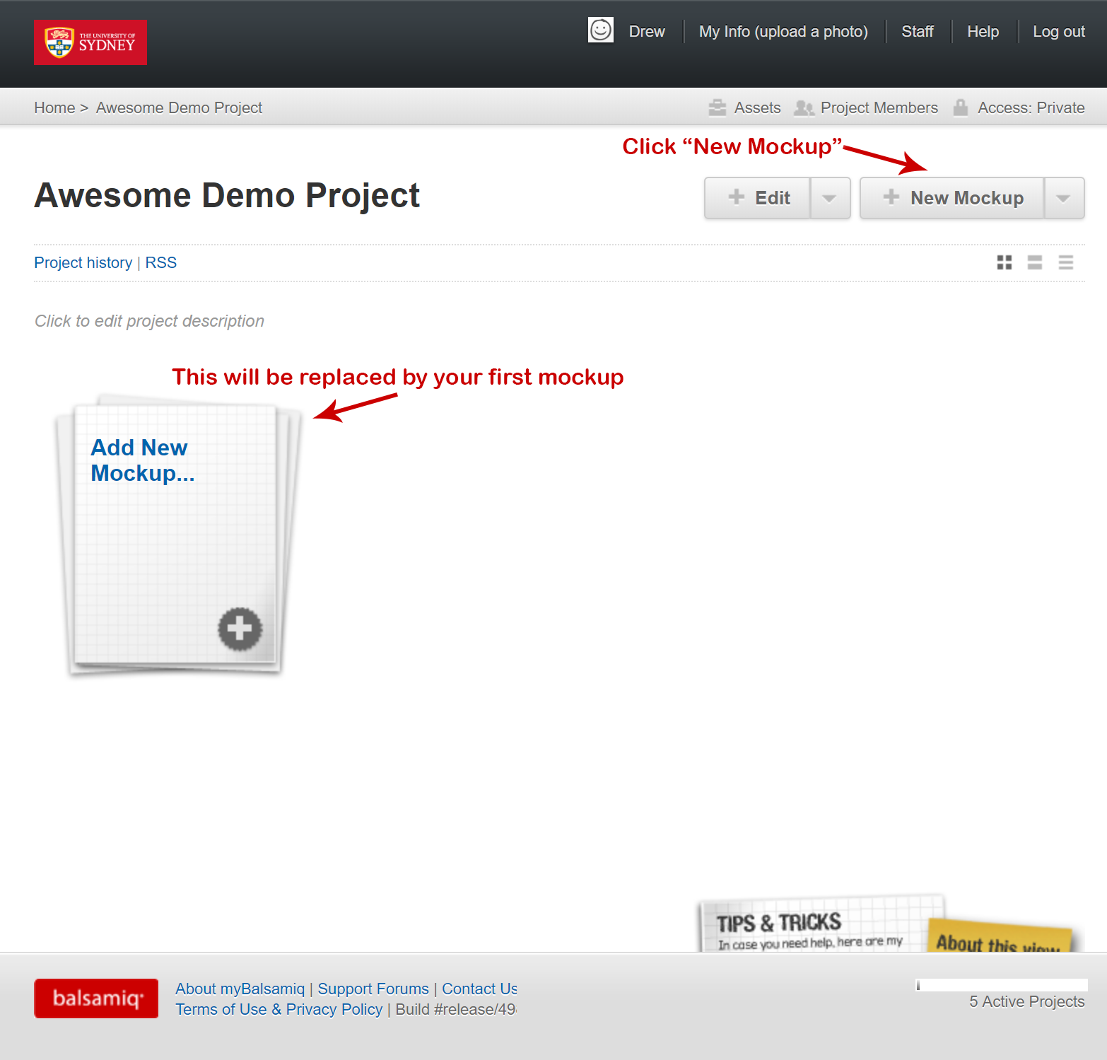

Once you have saved a mockup, the screen will appear like this:

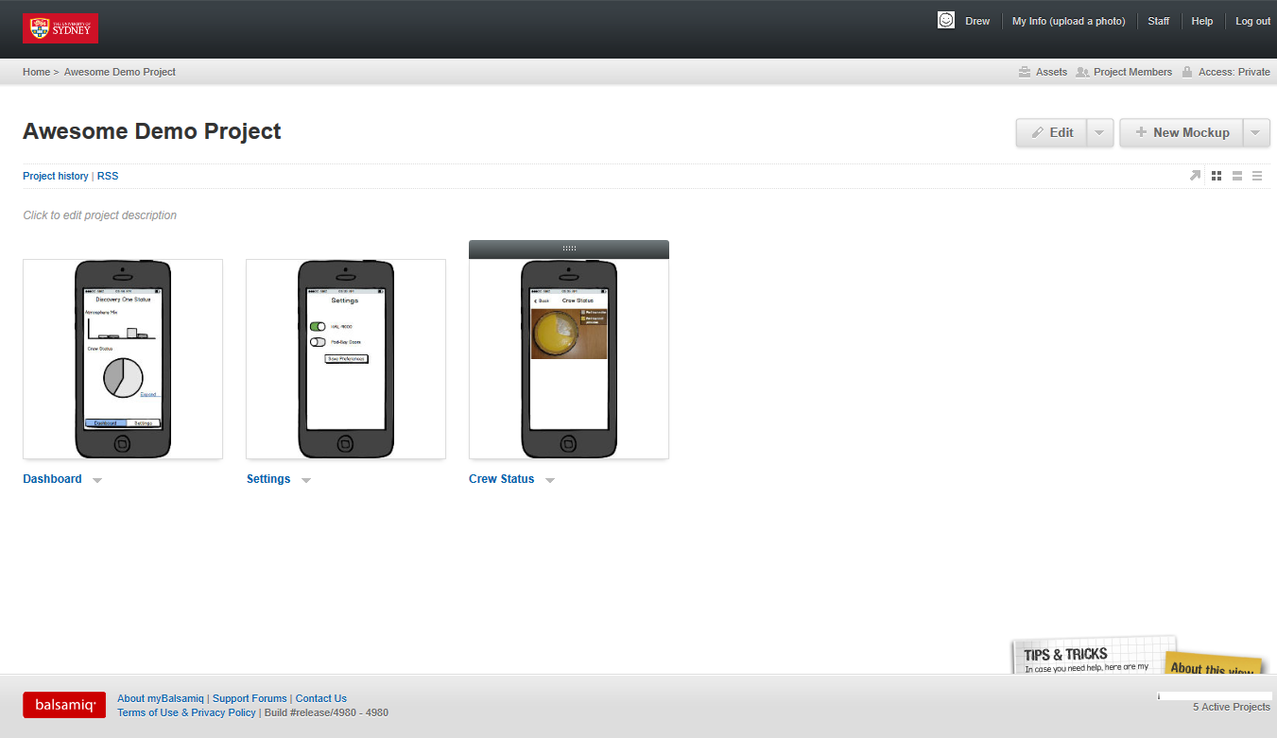

## Mockup editor

myBalsamiq’s editor interface should be familiar if you have used other drawing/diagramming tools. The gridded pane on screen is your *Canvas*, where you can add elements to create your prototype.

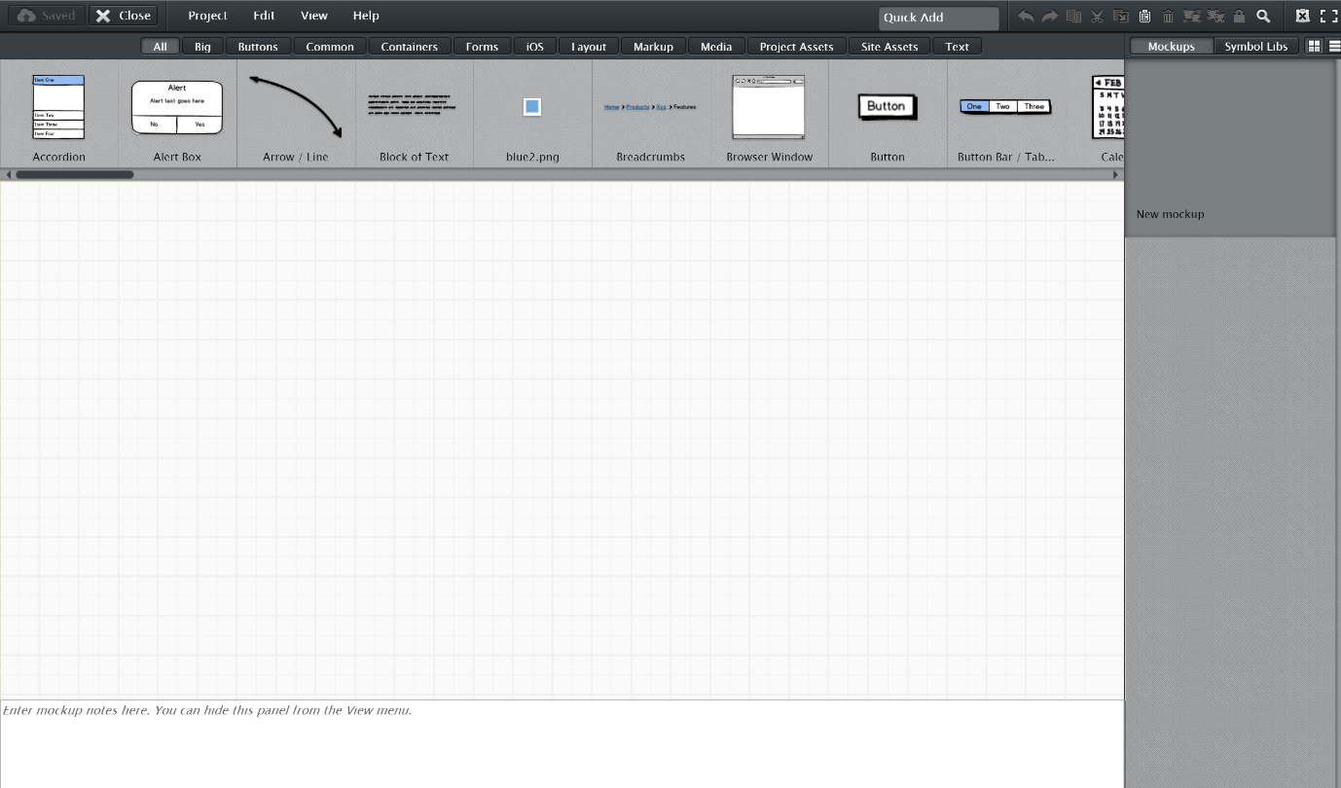

In Balsamiq UI elements are known as *Controls*. In other tools these may be known as widgets. The controls included in Balsamiq cover desktop, iOS and web. These are located in the bar just above the canvas.

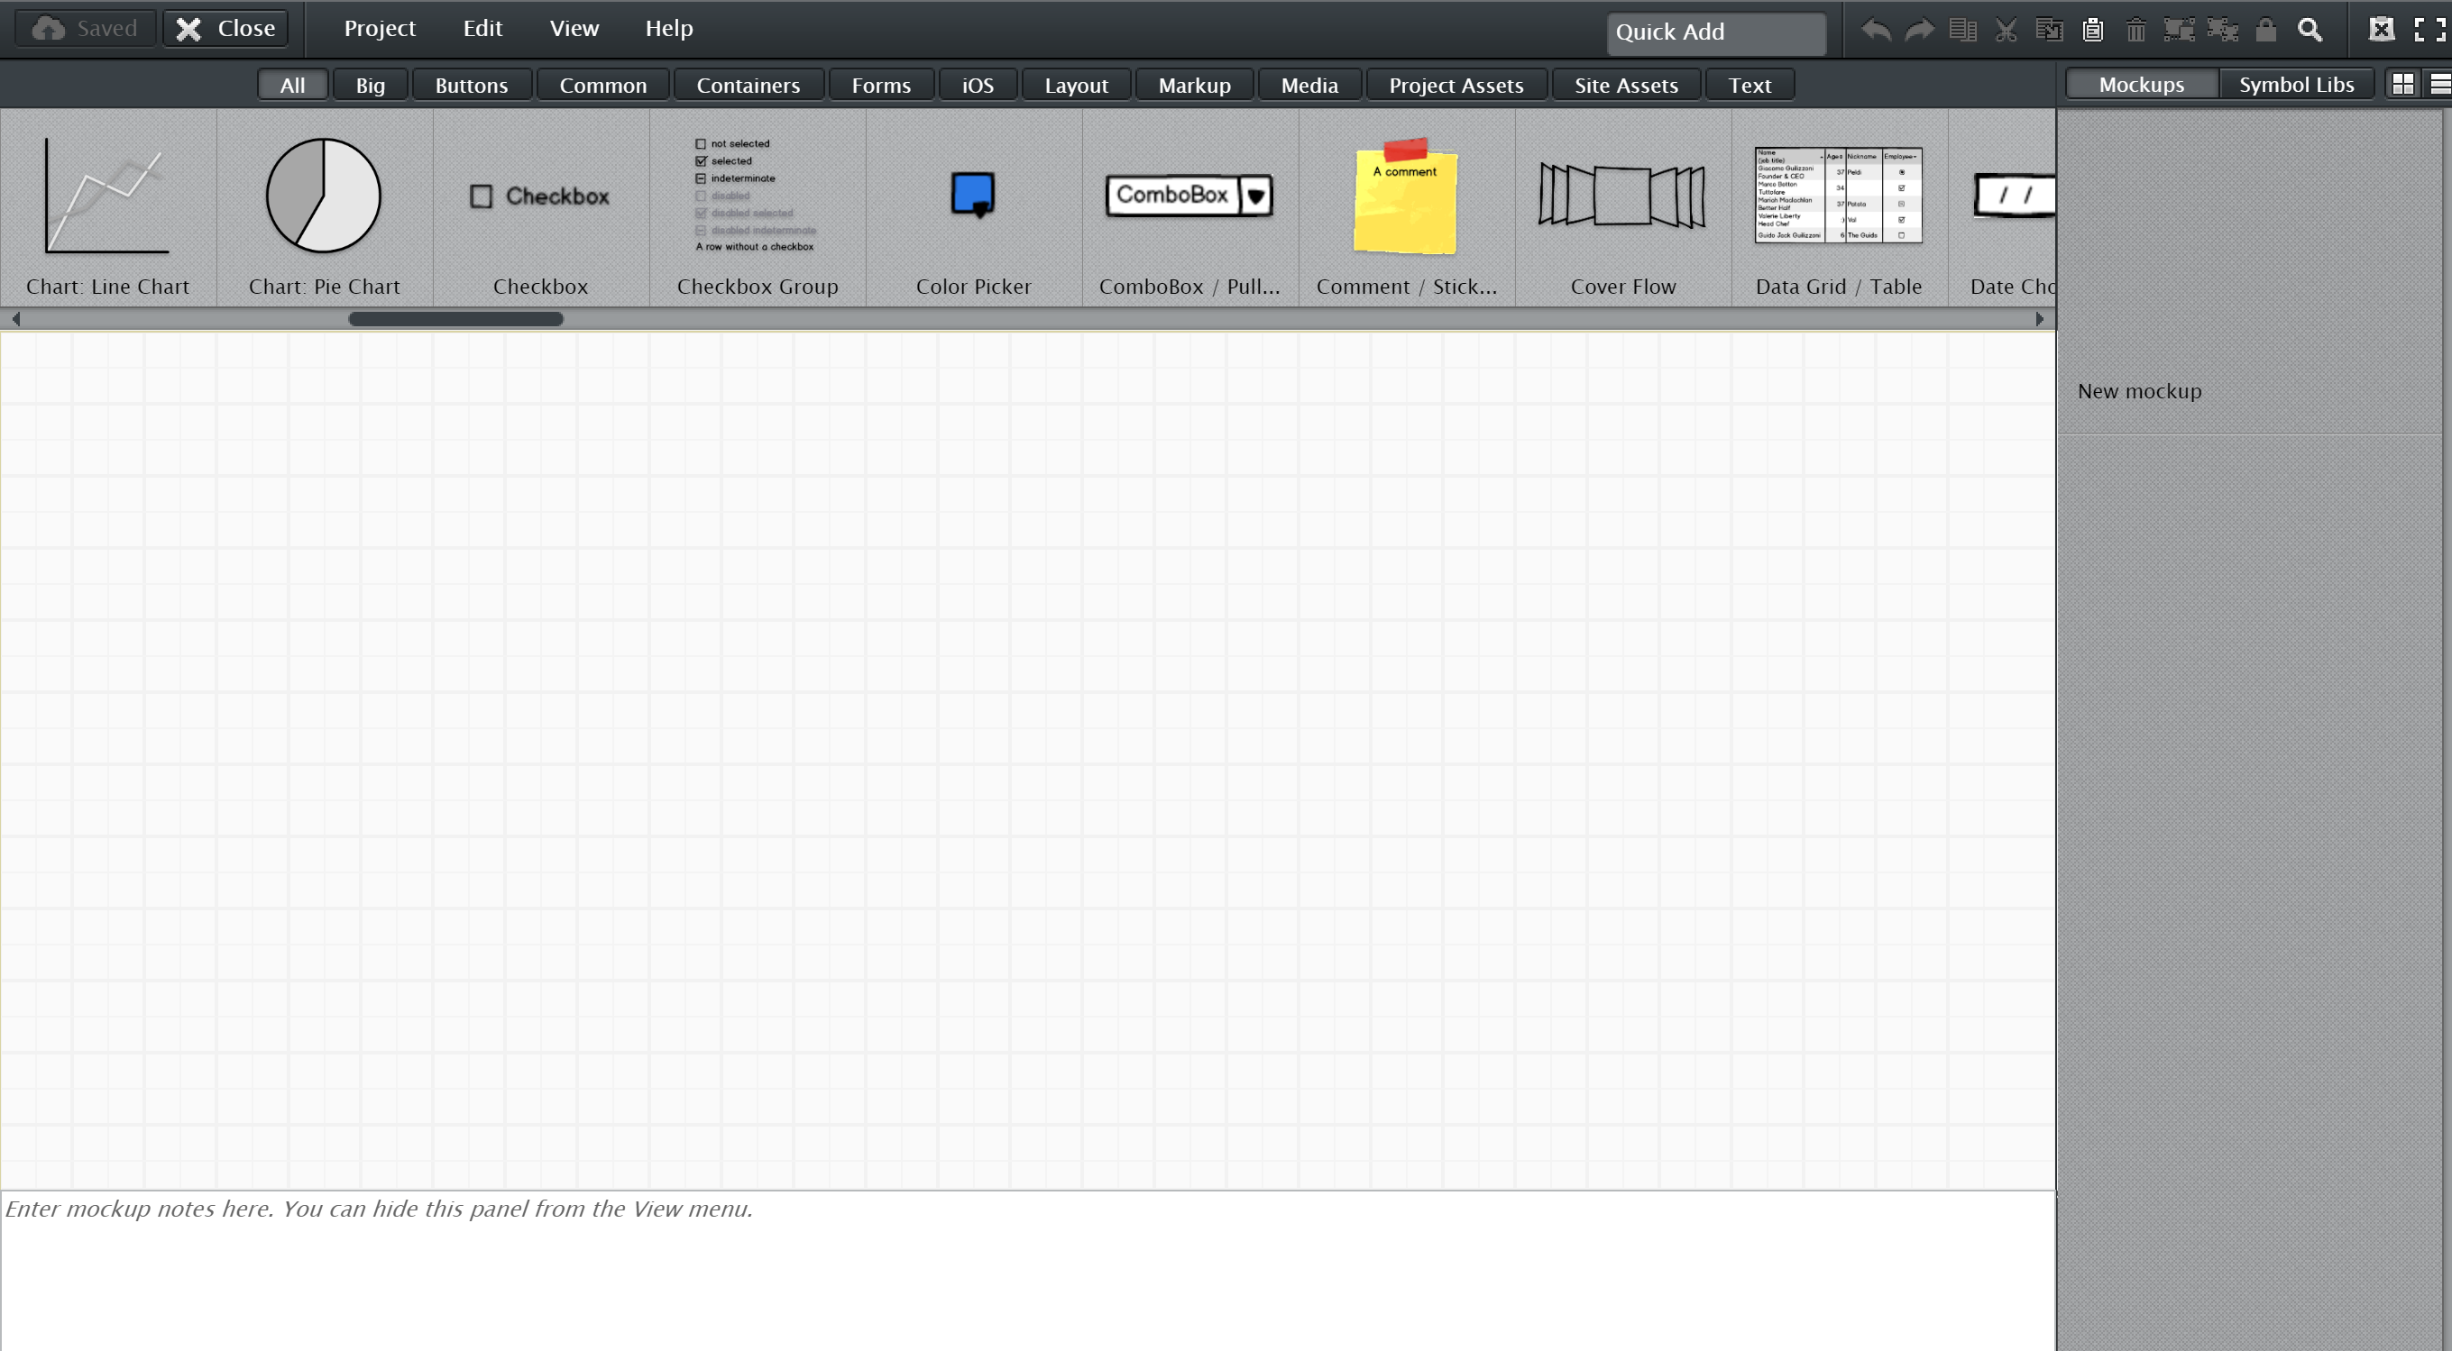

A screenshot of a computer

Description generated with high confidenceThe canvas allows you to create your prototype. Including containers representing a mobile phone, tablet or browser window. The control pictured to the right can be found in the Control picker > *iOS* > *iPhone*.

Modals – or pop-up windows – are used throughout myBalsamiq to change the appearance or functionality of each control. For a title, or other text-only control, you have basic text-formatting options. Just remember: **don’t get bogged down with visual design.**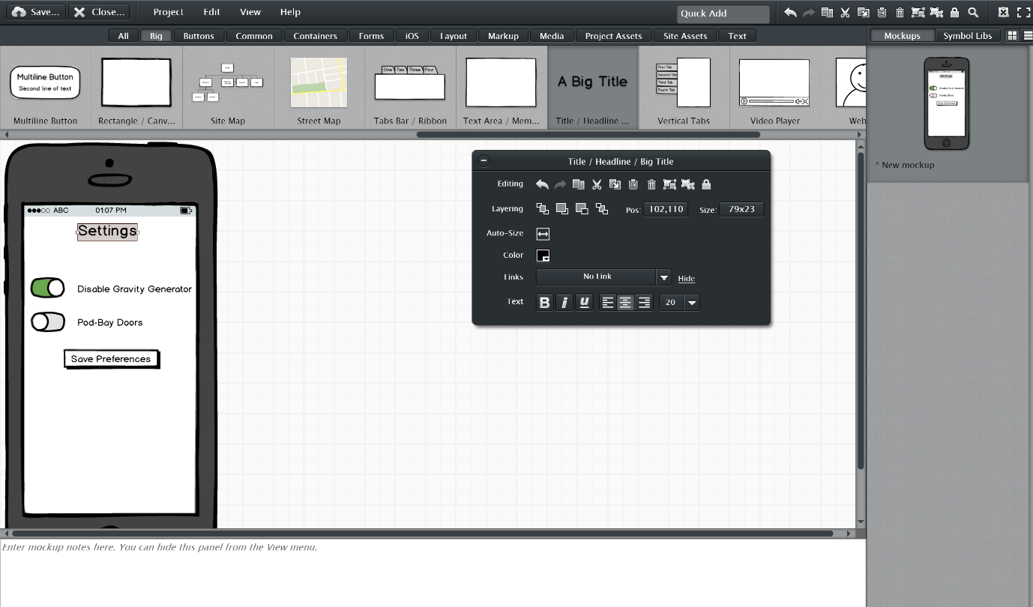

Most elements containing text can be edited by a double-click. For items that allow multiple options, these options can be provided in a comma-separated format.



# Managing your Project

## Saving

myBalsamiq keeps a history of changes for each mockup. The note field in the save window is treated similarly to a Git commit message. Make sure these messages explain a little bit about what changes you made.

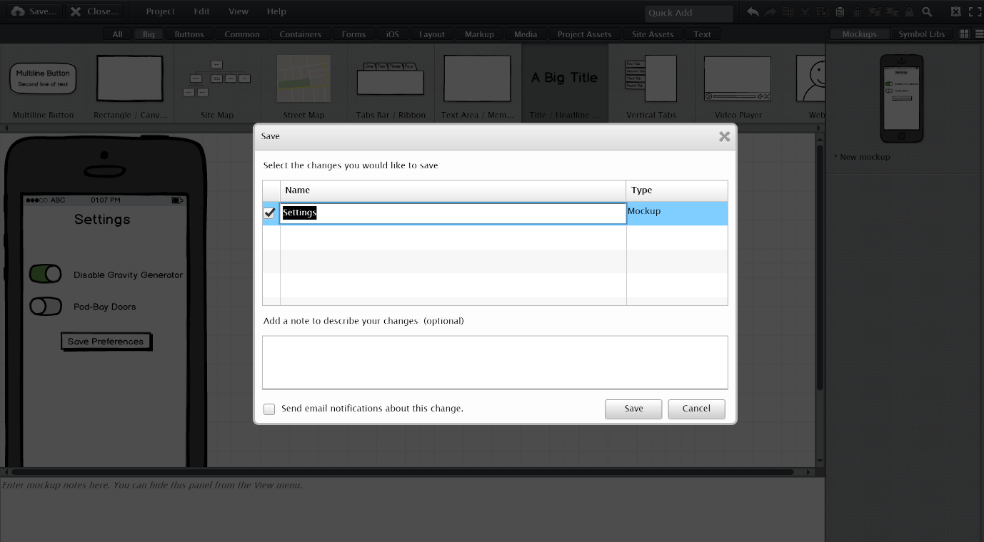

These messages can be viewed in the Project History link from the project home screen.

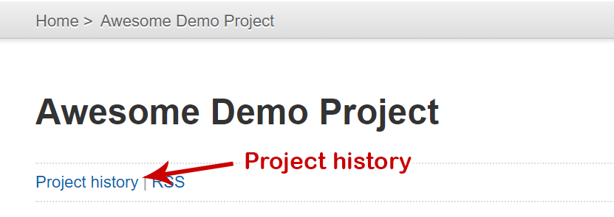

Remember that these messages aren’t intended to help you right now. They are intended to help you (and your teammates) remember what happened 3 weeks ago[3]. Try to put helpful descriptions to serve as a good reminder of what you are doing.

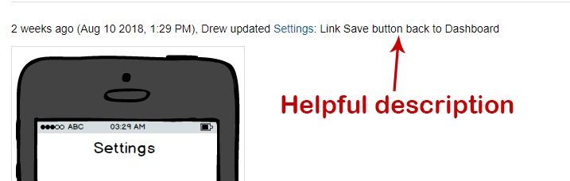

## Organising your mockups

You may find after creating a few screens that you need to reorder their display to suit the logical flow of your prototype. This can be done from either the project home screen, or from the Mockup Editor.

From the home screen, hover the mouse over a mockup, then drag the grey grab-bar into the new position.

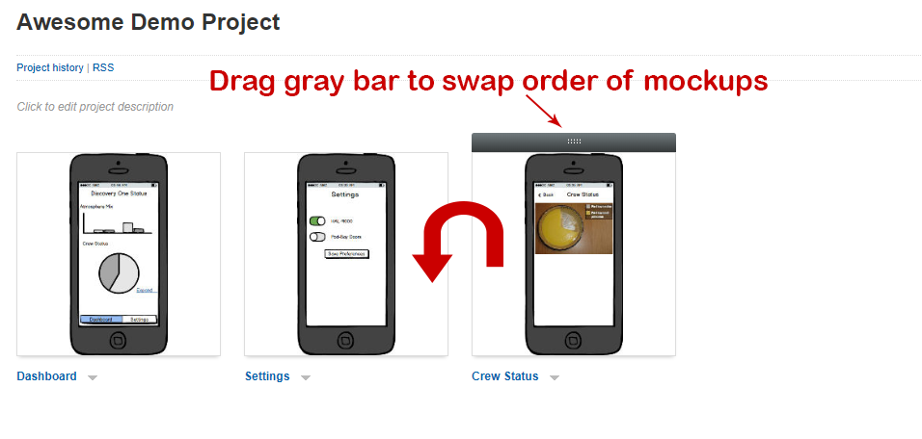

From the mockup editor, the grab-bar is hidden but the process is similar:

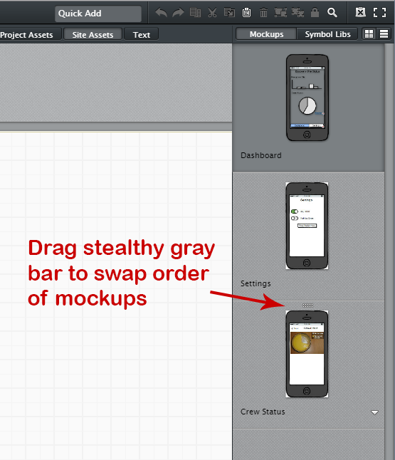

# Linking Mockups

myBalsamiq allows clickable links to be created between the individual mockups to create a *click-through prototype*. This will allow you, or usability testing participants move between screens in the same manner that they may do with an implemented UI.

This comes with a few limitations as the prototype is low-fidelity that you should be aware of:

* Mockups cannot change state:
  + Controls cannot be interacted with
  + Labels/text elements cannot be changed dynamically
  + Data cannot be loaded in from elsewhere

These limitations are intentional by myBalsamiq’s developers. Low-fidelity prototypes should be concerned with testing the creator’s assumptions about how the UI will work, not attempt to provide an implementation of it.

Not all UI controls support being linked, but many do. Explore the list of controls to find them all.

Some controls like Image, Button and Link support a single link target:

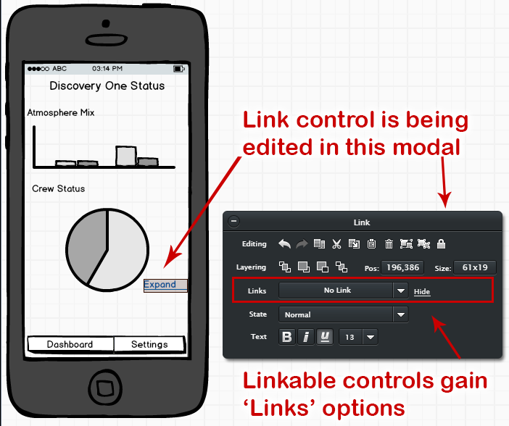

When clicking the dropdown list in Links, you can select one of the other mockups that exist in your project.

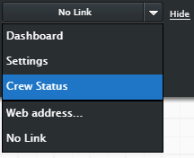

Controls like Button Bar, Link Bar, Menu Bar and Tabs Bar support multiple link targets – one link per item in the bar.

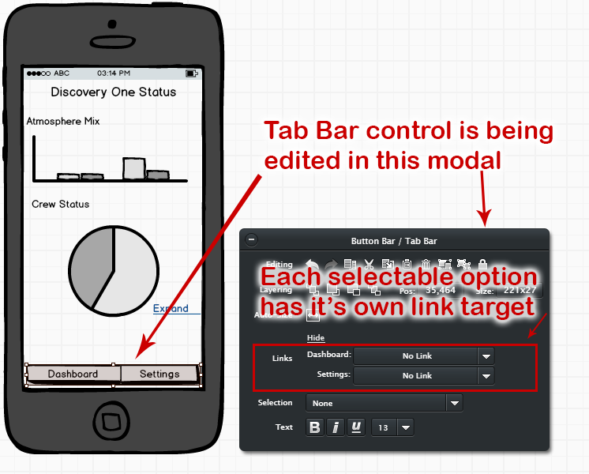

Note: The “Selection” option allows one of the items in the Button Bar to be highlighted. This may be helpful if the button bar is present on multiple mockups in your prototype. The highlight can indicate which mockup is currently active.

A nice walkthrough of this process has been uploaded to YouTube by the myBalsamiq developers. This is at [**https://youtu.be/PeV4gF0b-Xk**](https://youtu.be/PeV4gF0b-Xk) and detailed documentation at **https://docs.balsamiq.com/mybalsamiq/linking/**

# Assets

While myBalsamiq has a broad range of UI controls, it doesn’t include everything you might need to do. Therefore, *Assets* can be used to upload your own images into myBalsamiq.

Assets can be organised in two ways, at *Site* level – where every group in the myBalsamic account can see and share the asset – and *Project* level where it’s limited to a single project. Please upload only Project level assets to avoid this becoming a free-for-all.

## Uploading new assets

From your project homepage, click Assets in the top bar.

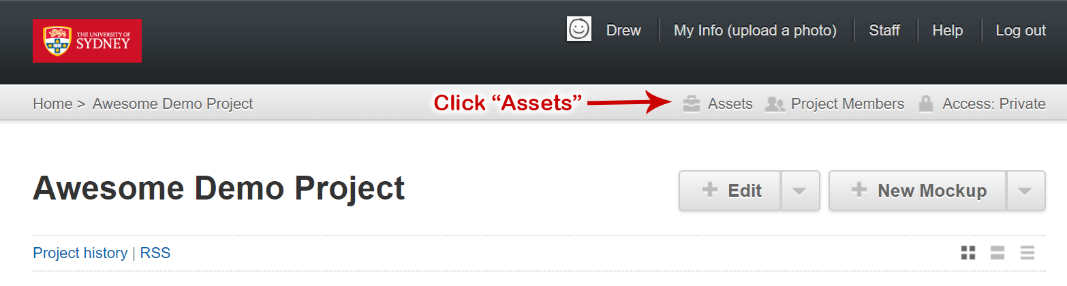

This brings up a modal, with a button labelled Upload:

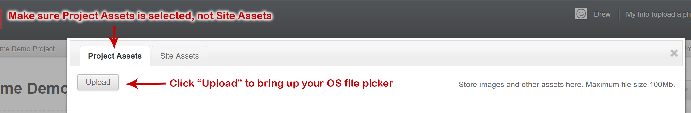

## Using uploaded assets

Once uploaded, assets behave like any other control in myBalsamiq. They can be found in the Project Assets tab of the controls bar in the Mockup Editor.

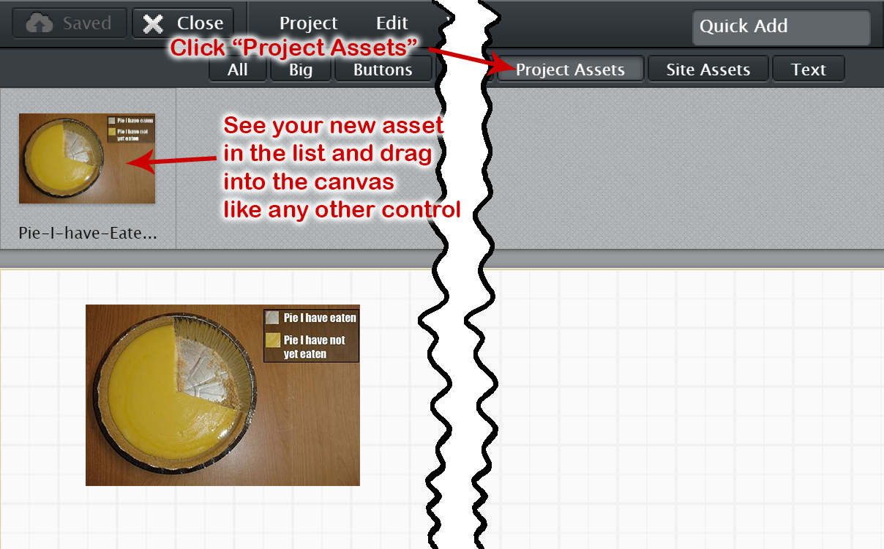[4]

# Summary

At this point you have been introduced to:

* Rationale of Balsamiq software
* How to create an account from an invite
* How to use the myBalsamiq Mockup Editor
* How to organise projects and mockups
* How to create a linked prototype
* How to upload and use custom assets

# More Resources

myBalsamiq is well documented being a mature project. Its docs are at [**https://docs.balsamiq.com/mybalsamiq/**](https://docs.balsamiq.com/mybalsamiq/)

Another good “getting started” guide is at **https://support.balsamiq.com/tutorials/firstwireframe/**

With some more tutorial videos and resources at  
**https://support.balsamiq.com/tutorials/**

Balsamiq is widely used in the UX Industry - lots of guides and tutorials available for the Balsamiq Desktop and Cloud tools are largely applicable to myBalsamiq.

1. Yes, myBalsamiq is deprecated in favour of Balsamiq Cloud.
2. *Italicised blue text* indicates terminology used in myBalsamiq. These keywords may be helpful when searching for documentation or tutorials.
3. To paraphrase the golden rule of coding: *Always design as if the person who ends up maintaining your mockup is a violent psychopath who knows where you live* [http://wiki.c2.com/?CodeForTheMaintainer]
4. The scribbly line is used here to cut out the middle of the screenshot since it’s irrelevant to what I’m trying to show.